

SETTING UP A LAST MILE CONNECTION FOR A SITE

VERSION: 0.0.1
AUTHOR: HAPPY CHIKUSE
DATE: 02/11/2017
LAST UPDATE:

- Introduction
- Tools to be used.
- Check line of site to nearest point of present
- Determine the position to Mount Antenna
- Antenna allignment
- Configuring the radios
5.1 Configuring Mikrotik Routeros Based radio
5.2 Configuring Ubiquit Airmax M Based radio
- Configuring Router
- Configuring Server

1. Introduction

This SOP will describe the process of setting up a last mile wireless connection for a facility. This document assumes that an access point on the transmitting end is already setup and is broadcasting radio signals

2. Tools

remember to have the tools listed below when going to site
- Compass for line sight
- Linux Laptop with wine and winbox installed
- Crimping tool
- Set of spanners and screw drivers

2. Line Of Site

Refer to Last Mile Connection Survey SOP Ver: 0.0.1

3. Antenna Position

The below factors determine the position for mounting the antenna.
- The Position should give maximum height for line of site to the transmitter.
- Consider the nearest connection point to the local area network(LAN)
- Position which is easier to mount

4. Antenna Alignment

- Determine the direction of transmitter by checking where its azimuth is pointing on the compass.
- Align the antenna by pointing the antenna to the direction where the azimuth of your transmitter is pointing.
- Tighten the antenna

5. Configuring the radios

Here the two commonly used radios are described, these are the Ubiquit radio using the airmax M software and the Mikrotik radios using routeros.

5.1 Login to your new radio device

- Connect the cable from the radio to your laptop
- Assign your laptop ip address 192.168.88.100/24
- Check if you are able to reach the radio on its default ip address by pinging 192.168.88.1 if its responding go the next step.
- Open winbox and connect to 192.168.88.1 use username admin and no password

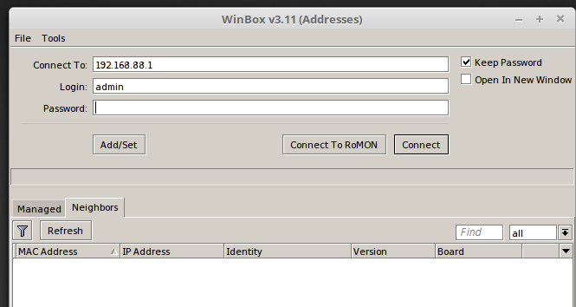

5.2 Setting up the radio connection

5.2.1 On the main menu click on wireless
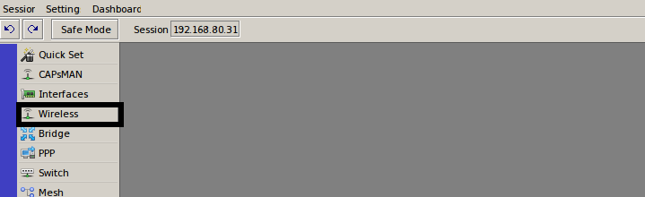
5.2.2 Set Security profile to be used for the wireless connection, this should match the one set on the transmitter.
5.2.2a Click on security profiles tab

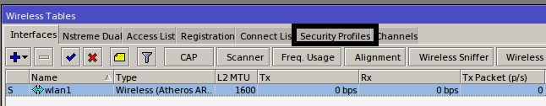

5.2.2b add a new profile by clicking on the add symbol

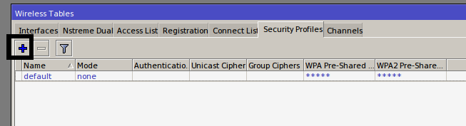

5.2.2.c Set the following parameters then click on apply

Name: any descriptive name for your profiles
Authentication type: set this to WPA2 PSK
Unicast Cipher: set this to aes ccm
Group Ciphers: set this to aes ccm
WPA2 pre-shared key: set this according to the key which set on the transmitter

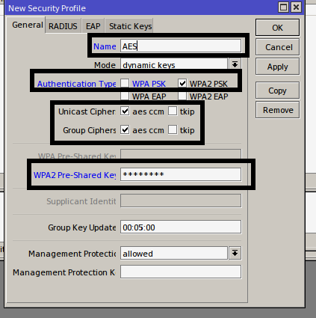

5.2.3 Under interfaces double click on the wireless interface to configure it

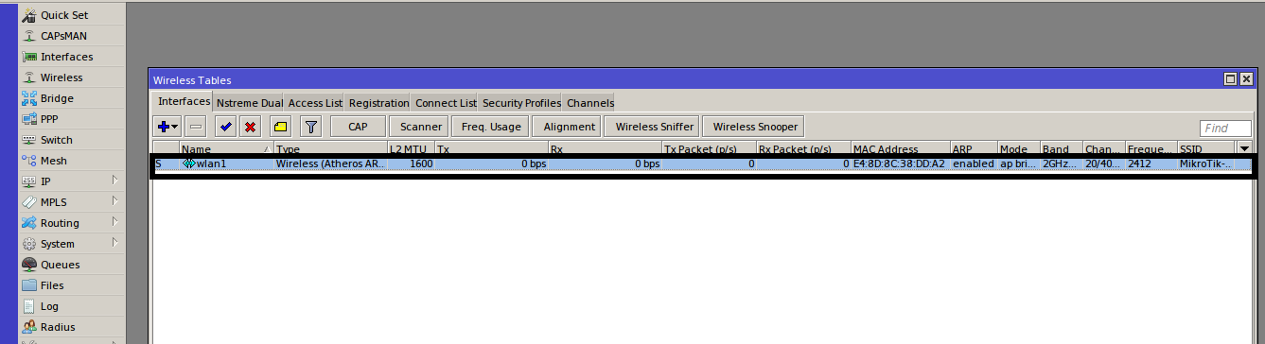

5.2.3a Set the interface Mode, Frequency, channel width and click on apply, then click on apply to view the available wireless networks

Mode: Should always be station bridge
Band: Should be set according to the Frequency Band of the transmitter in the figure below 2GHz with support for wifi standards 802.11 B/G/N is used.
Channel Width: This should be set according to what was set on the transmitter in the figure below 20/40mhz Ce was used. Ce Means Control and extended channel, so 20/40mhz Ce Means the control channel is 20Mhz and the channel can be extended up to 40Mhz
Security Profile: Select the security profile created earlier by clicking on the security profile drop down menu.

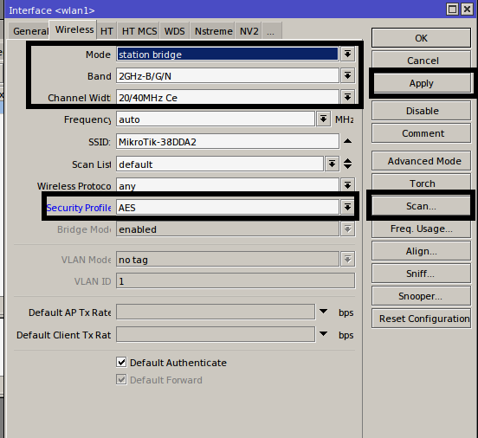

5.2.3b Choose your wireless network name (SSID) from the scanner by clicking on the ssid in the figure below we are connecting to ssid support-office2.

Note: A good Signal should be between -75 below anything above If you get above -75 you may need to realign the antenna to get the best signal.

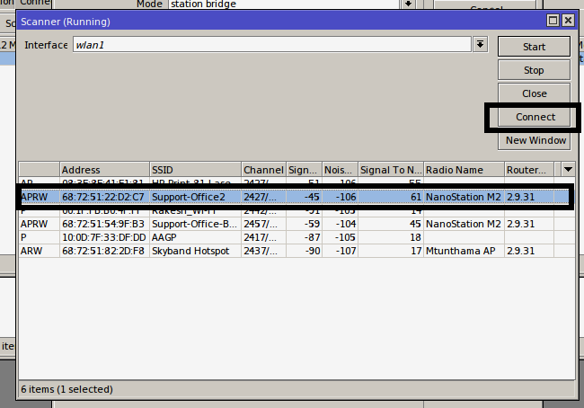

- When connected the wireless interface status changes from S to RS as shown in the below picture

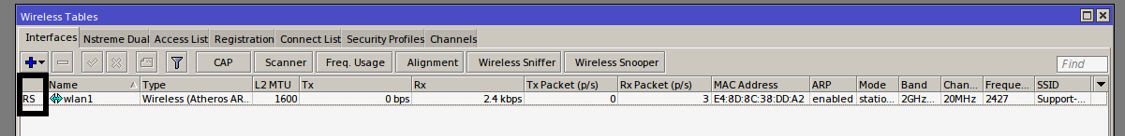
- To further verify connectivity click on the registration to view the wireless registration details as shown in the picture below

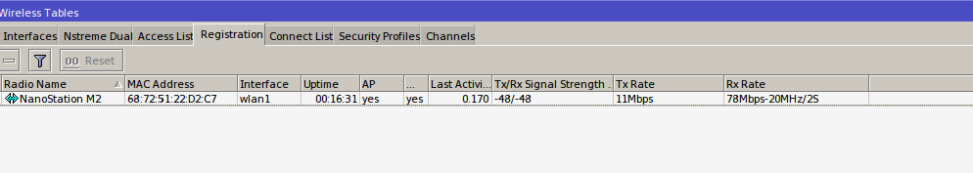
- in the picture above the most important information to check is the Tx/Rx Signal strenth, Tx and Rx Rate and the uptime.

SET UP BRIDGING

We want our radio to utilize its resources on the wireless link and nothing else so, so we will turn the routing capabilities and let it do bridging. Routing will be discussed later in this SOP.

Create the Bridge
To Achieve this on the main menu click on bridge as shown in the picture below.

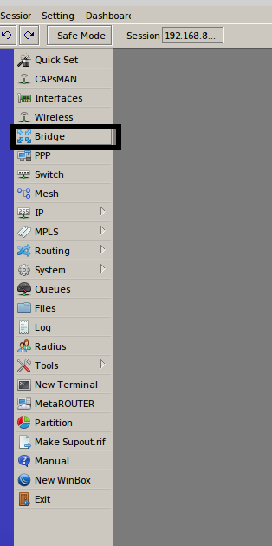

Under Bridge Click on the add symbol to create a new bridge. Set the below parameters and leave the other settings to defaults. Click apply to save.

Name: any descriptive Name for the bridge
Admin. Mac Address: Set this to be the mac address of your wireless interface.
Steps to get your wireless interface mac address Main Menu > Click on Wireless > Double click your Wireleess Interface > Click on General
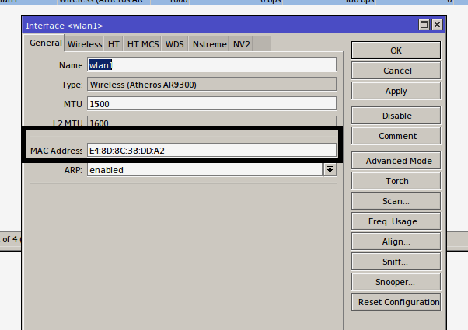

the bridge configuration should look like the below picture.

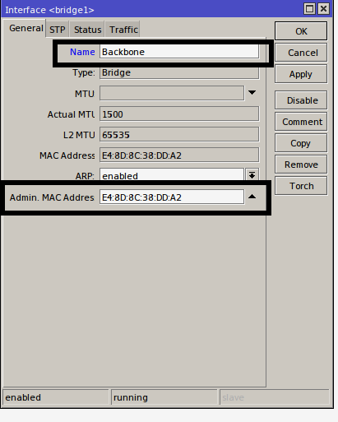

ASSIGN IP ADDRESS TO THE BRIDGE

Go to the Main Menu, click on IP then Addresses
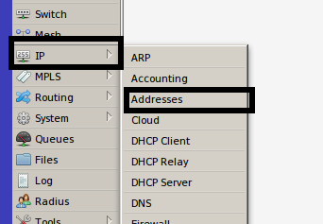

Under address list click on the add symbol to add your address

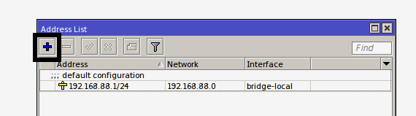

Set the ip address assigned to you from engineering, this address should be assigned to the bridge interface created above.

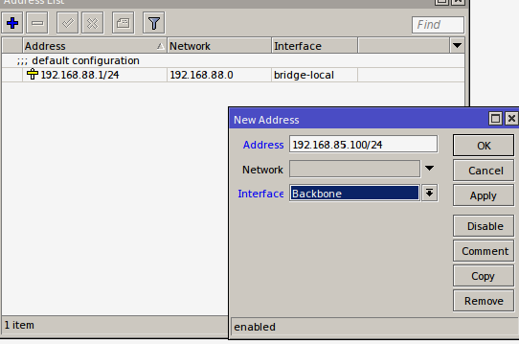
Once the ip address is assigned to the bridge the ports can now be assigned to the bridge

Go back to the bridge Menu by clicking the Main Menu then Bridge on the bridge Menu click on ports

the wireless and the ethernet interface are already configured to the default bridge, lets change this so that our ports start using the ip address which has just been added.

- To avoid loosing connectivity to the radio we edit the wireless interface first. Double click on the wireless interface, in this example the interface is labeled wlan1, then under general change the port`s bridge by clicking on the bridge drop down menu and select the new bridge “Backbone” click apply to save. as shown in the picture below.

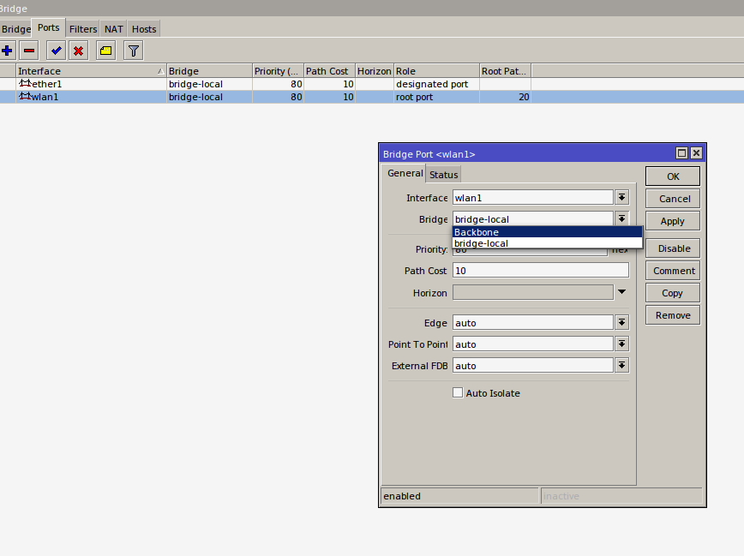

Then do the same with the ethernet interface, after applying the settings on the ethernet interface, connectivity to the device is lost, to gain access back to the device login with the new ip address.

CHANGE DEVICE IDENTITY

For Easier identification especially when you are connected to multiple devices you need to change the identity of the radio to achieve this:

On the main menu click on system then identity

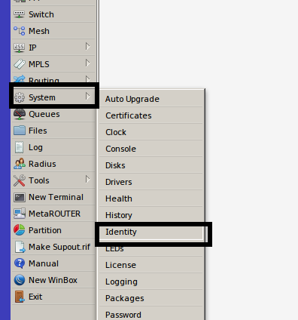

Change the identity from the default mikrotik to something easier to identify, in this example the identity is set to “LASTMILE” click apply to save.

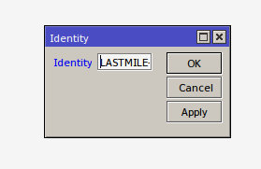

SET DEVICE PASSWORD

By default the device has no password so we need to assign it a password to restrict access to the device.

On the Main Menu click on system then click on password

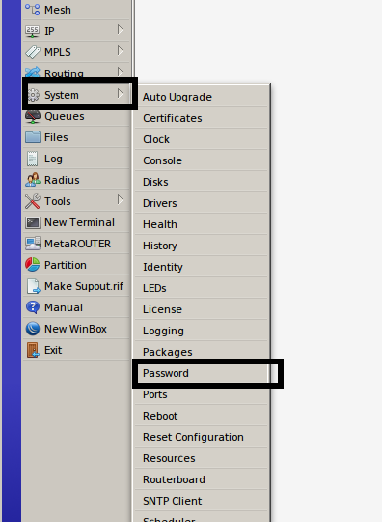

Leave current password blank, assign the new password and then confirm the new password by retyping the password when done click on change to save the new password.

